Handout 1: The Gamble Plantation Worksheet
Day 1 Learning Activities
Let’s Think!
When I think of plantations and political systems, I think of....

When I think of plantations and economic systems, I think of....

When I think of plantations and social issues, I think of....
______________________________________________________________________________
Let’s See!
Image 1: What do I see in this image?
At first glance I see...

At second glance I see...

What do I not see in this image?

Why may that absence exist?

What history is highlighted?

What history might be missing?
Image 2: What do I see in this image?
At first glance I see...

At second glance I see...

What do I not see in this image?

Why may that absence exist?

What history is highlighted?

What history might be missing?

Image 3:
What history is highlighted? What history might be missing?
________________________________________________________________________________________________________________________________________________________________________________________________________________________________________________________________________________________________________________________
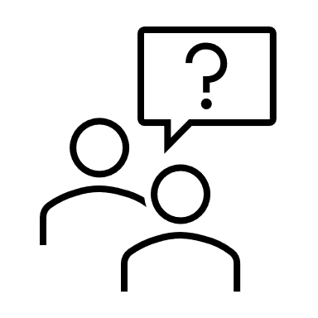 Based on the documents, maps, and photographs, what role did slaves play in the establishment of the Gamble Plantation?

Day 2 Learning Activities
“But where are the memorials to the slaves? Where are their markers? Where are their names?”
__________________________________________________________________________________________________________________________________________________________________________________________________________________________________________________________________________________________________________________________________________
Let’s See!
Observations
Image 1: | Image 2:

Let’s Think!
- What message is John Sims trying to make with his art at Gamble Plantation?

- In what ways does John Sims art installation address historic silences at Gamble Plantation?

